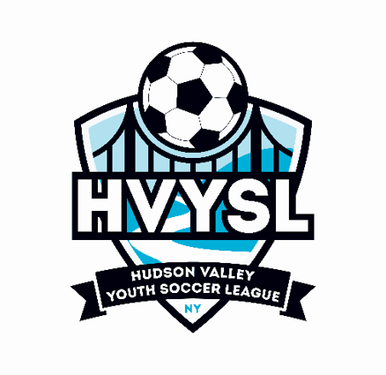

MICHAEL GOLDBERG SCHOLARSHIP Two $1,000

DAN HERBST SCHOLARSHIP Two $500

ELIGIBILITY

To be eligible to apply for the scholarship all applicants must:

be a graduating High School Senior the year of the application

have a minimum overall high school average of: Michael Goldberg 80% Dan Herbst 80%

be entering a full-time four-year College or University, in a program leading to a bachelor's degree, in the Fall following graduation.

have participated in the Hudson Valley Youth Soccer League for at least three (3) league years. (Said participation need not have been in successive years but must include at least participating during the applicant's Junior and Senior year of High School

APPLICATION (Attached)

All entries must be completed and submitted to the Scholarship Committee no later than June 15th of the applicable year. Please include a digital graduation picture.

SUBMISSION

e-mail Applications to the Scholarship Committee and HVYSL office at soccer@hvysl.org, mlabrenz@hvysl.org, llabrenz@hvysl.org, eruppert@hvysl.org, and jholness@hvysl.org.

AWARDS

The applicant that, in the opinion of the Committee, receives the most points and in all other areas stands out among his or her peers, will be awarded these scholarships.

CRITERIA

The applicant will be judged based on academic performance, athletic accomplishment and sportsmanship. Academic performance will be demonstrated by high school transcript, SAT scores and recommendations.

Athletic performance and sportsmanship will be demonstrated by the recommendations of the applicant's high school and/or H.V.Y.S.L. soccer coach or Club President, honors such as "All Scholastic" or divisional high school selection, membership on the H.V.Y.S.L. or other select teams and the absence of unusual disciplinary penalties. Leadership qualities such as being Team Captain will also be considered.

Contributions to the community are a consideration for the Michael Goldberg & Dan Herbst Scholarships and can be demonstrated via an attached resume.
Hudson Valley Youth Soccer League Scholarship Application

Complete all six parts before submitting

PART I
NAME:
ADDRESS:
ZIP
PHONE: SOCIAL SECURITY:
DATE OF BIRTH:
HIGH SCHOOL:
FATHER'S NAME: MOTHER'S NAME:
OCCUPATION: OCCUPATION:

PART II

H.V.Y.S.L. years played (List last 3 years - Present year can be included)

YEAR CLUB TEAM OR COACH

- __________________________________________________________________________________

- __________________________________________________________________________________

- __________________________________________________________________________________

PART III

Name of college or university you have been accepted by and plan to attend. (Enclose photocopy of acceptance, if available, or attach a list of all schools applied to)

PART IV (Attach the following items)

A. A letter of recommendation from School Principal, Guidance Counselor or Faculty Advisor.
B. A letter of recommendation from Club Official or school or club coach.
C. A current copy of high school grade transcript.
D. A copy of SAT scores as supplied by The College Board Testing Service.
E. A current (Graduation) Picture.

PART V
Submit a brief resume outlining awards, achievements, volunteer work, employment, school clubs, etc. between the ages of 14 to present. A 250-to-500-word essay on “How Soccer Has Influenced My Life.”

PART VI
Submit any other relevant information including unusual financial need.

